Norm | RCN-217  RailCom  DCC-Rückmeldeprotokoll
Ausgabe  02.12.2018 | RCN-217  RailCom  DCC-Rückmeldeprotokoll | RailCommunity – Verband  der Hersteller Digitaler  Modellbahnprodukte e.V.

This Recommended Practice received approval from the NMRA Board of Trustees in March 1997, July 2002, July 2003 and January 2006. Changes since the last approved version are indicated by change bars on the left or right side of the document. Changed to Standard July 2012.

Contents
1 General 4
Purpose of the Standard 4
Requirements 4
Explanations 4
2 Physical Layer 5
General 5
RailCom transmitter in the decoder 6
The RailCom Detector 7
Timing 8
4/8 Encoding 10
3 Packet Layer 11
RailCom command MOB decoder 12
RailCom command type STAT 13
4 RailCom CVs and DCC Commands 16
System Requirements 16
CVs 16
CV28 RailCom Configuration 16
CV29 17
CV31, CV32 17
RailCom Block 17
DCC Commands 18
Additional function 18
Advanced Programming 19
NOP for Accessory Decoder 19
5 Applications Layer for Vehicle Decoder 21
POM (ID 0) 21
Byte Read 21
Byte Write 21
Bit Write 22
ADR (IDs 1 & 2) 22
Dynamic channel 1 usage 23
Aufgleissuche 24
EXT (ID 3) 24
Send the location information 24
fill 25
DYN (ID 7) 25
XPOM Byte Read 29
Byte Write 29
Bit Write 29
Test Feature ID (ID 12) 29
List of previously issued Test Feature IDs 30
6 Application for accessory decoder (switches, etc.) 30
SRQ - Service Request for Accessory Decoder 30
POM (ID 0) 32
Byte Write 32
Byte Write 32
Bit Write 33
STAT1 (ID 4) 33
TIME (ID 5) 34
ERROR (ID 6) 34
DYN (ID 7) 36
XPOM (ID 8 to ID 11) 36
STAT2 (ID 8) 36
Appendix A: References to other Standards 38
A.1 Links to Referenced RCN‘s 38
A.2 Informative Links 38

General

Purpose of the Standard
This standard describes the transmission of data from the decoder over the track to a receiver, ie in the opposite direction to the control protocols. The transmission method described here together with the protocol used is called RailCom.
"RailCom" is a German brand registered in the name of Lenz Elektronik for the class 9 "Electronic Controls" under the number 301 16 303 as well as for the classes 21, 23, 26, 36 and 38 "Electronic Controls for Model Railways" in USA registered under Reg. No. 2,746,080 Trademark. European Patent 1 380 326 B1 was repealed. RailCom is thus freely usable under consideration of the trademarks.
This specification applies exclusively to the use of RailCom within the DCC data format (protocol). The use of RailCom within other data formats is not permitted.

Requirements
In order to comply with this standard, all technical values ​​and protocols defined in this standard must be complied with. Tables 5 and 6 define which messages from a decoder should at least be supported.

Explanations
A DCC data packet is a defined sequence of bits described as a track signal in [RCN210].
Bytes are bit groups of eight bits each.
Each bit in the byte has a significance dependent on its position, the first transmitted bit left in the representation has the highest significance and is called MSB "most significant bit". The bits of a byte are numbered starting from the left beginning with 7, falling right to 0. The last bit transmitted in the representation is called LSB "least significant bit".
The following characters are used to indicate the meaning of a bit:
0 Bit value 0
1 Bit value 1
A Address bit
D data bit
P Location information (position)
R Direction bit
S Sequence number
T Type of location information
X Subindex
The characters used in the DCC commands are not listed here again.
The bit combinations for DCC represented in the box in this standard are purely informative and have no normative character. Only the specified RCNs apply here.
The commands from the central unit to the decoder (►) are noted in each case without the addressing data. The addressing is done according to the DCC standard.
(◄) marks the sent RailCom data.
Unless otherwise stated, values ​​always refer to an 8-bit field. Binary values ​​are marked according to section 1.3. Hexadecimal values ​​are indicated by a prefix 0x.

Physical Layer
This chapter describes the physical layer of RailCom.

General
The flow of information in the DCC system normally takes place from the central booster over the track to the decoders. For the reverse transmission direction, it is necessary to interrupt this energy and data stream. This is done by the boosters, which generate at the end of each DCC package a so-called RailCom cutout by disconnecting the two track (track) lines from the power supply and short circuit. This function group within the booster is called "cutout device". Such a cutout device could also be run as a separate unit outside the booster. The actual data transmission takes place by means of a current loop. The decoder needs to provide the necessary power from its internal buffer. Figure 1 shows the arrangement of booster, detector and decoder during the RailCom cutout.
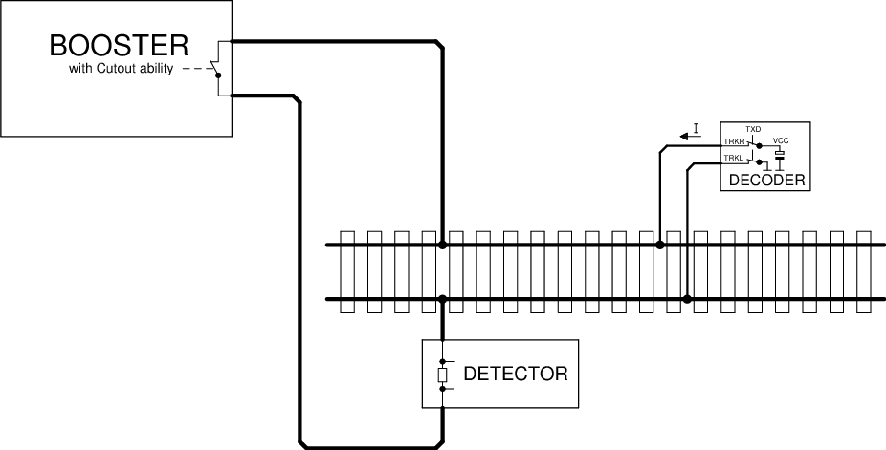
Figure 1: RailCom schematic diagram
The voltage drop across the cutout device must not exceed 10mV at a maximum of 34mA during the cutout.

RailCom transmitter in the decoder
In order to transmit a '0', the decoder must deliver a current I of 30 + 4 / -6 mA, with a voltage drop on the track of up to 2.2 V. If high-current RailCom is released in CV28, the decoder is Current 60 + 8 / -12 mA, also with a voltage drop on the track of up to 2.2 V. For a '1' the current I may not exceed ± 0.1 mA. The power source of the decoder must be protected against unexpected external voltage on the track during cutout. Figure 2 shows a possible hardware implementation.
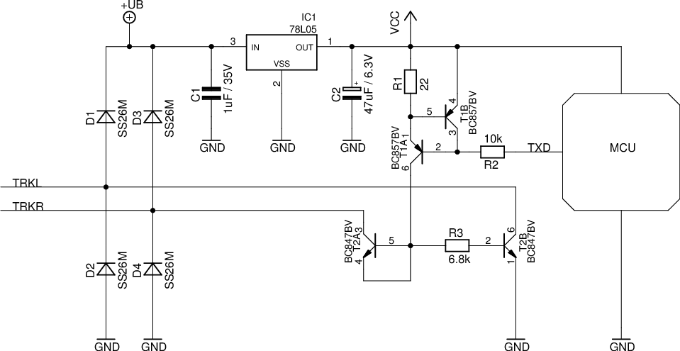
Figure 2: RailCom Decoder Hardware

Explanation of the circuit diagram:
The RailCom part consists only of the resistors R1 to R3 and the transistors T1A to T2B. T1A and T1B form a current source, T2A is diode-connected and protects the current source from positive voltages higher than Vcc.
All other parts of the circuit belong to the normally necessary hardware of the decoder. Note the extremely low hardware costs for the RailCom transmitter.

The RailCom Detector
A Detector must interpret a current greater than 10mA as '0' during the middle 50% bit time, a current less than 6mA during the middle 50% bit time as '1'. The voltage drop across the detector should not exceed 200mV at a maximum of 34mA during the cutout. Figure 3 shows a possible hardware realization.
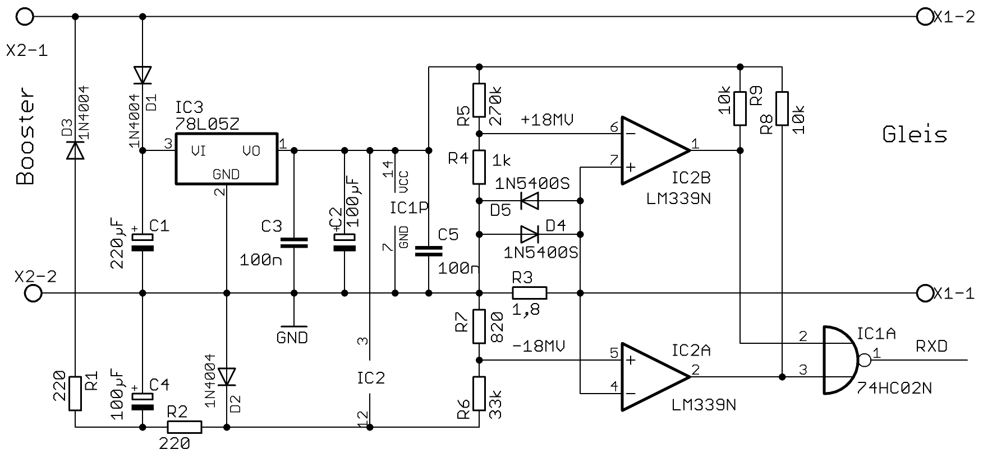
Figure 3: Example of a simple RailCom Detector Hardware
A maximum of two detectors (including the global detector) may be used in series, whereby the local detector should contain a connection for external evaluation of a track occupancy. If this is not the case, externally used occupancy detectors must be specified for RailCom. Explanation:
These circuits (transmitters and detectors) were tested on large club facilities up to a distance of 100m. This distance was easily bridged. It is not possible to use 5 ohm loads isolated from the track by bridge rectifiers, which are parallel to the measuring resistor of the detector.
The value of 5 ohms corresponds to a current of 3A at a track voltage of 15V.
Incandescent lamps (PTC thermistors) must always be operated via a fast bridge rectifier (<500 ns)..

Timing
Up to 8 bytes of data can be transferred in one cutout. Each transmitted byte begins with a start bit ('0') followed by the 8 data bits (least significant bit first) and ends with a stop bit ('1'). The transmission rate is 250 kbit / s ± 2%. The rise time (10% → 90%) and fall time (90% → 10%) must not exceed 0.5 μs.
The RailCom Cutout is divided into two channels. In channel 1 2 bytes, in channel 2 up to 6 bytes can be transmitted. Figure 4 shows the timing diagram. All times are related to the zero crossing of the last edge of the packet end bit.
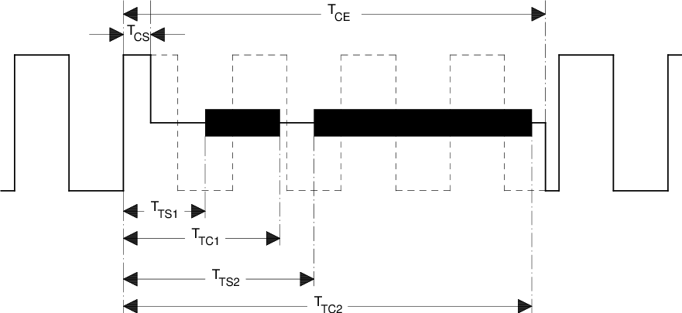
Figure 4: RailCom Timing

Parameter | Name | Min | Max
Cutout Start | TCS | 26µs | 32µs
Cutout End | TCE | 454µs | 488µs
Start Channel 1 | TTS1 | 80µs
End Channel 1 | TTC1 |  | 177µs
Start Channel 2 | TTS2 | 193µs
End Channel 2 | TTC2 |  | 454µs
Table 1: Timing Parameters
Comment:
The above figure shows the RailCom timing with "1" bits of 2 * 58μs (nominal value of the DCC "1" bit). For shorter "1" bits, it is possible for the cutout to reach the 5th "1" bit. However, this is not a problem since a central station must send at least 4 + 12 = 16 sync bits according to [RCN211] (packet end bit of the previous DCC packetbitsbits not counting the), so the decoder has enough sync(at least 11 syncmust be sent) for a recognition of the package by the decoder required) sees.
A cutout time of approx. 450μs must not affect the function of a decoder that does not control RailCom, as current interruptions up to 20ms have been detected on a real model railway layout, ie a decoder should be able to process at least one power interruption on this scale.

4/8 Encoding
Transmission is ensured via 4/8 coding, ie each transmitted byte contains 4 '1' and 4 '0' bits. If this ratio is violated, there is a transmission error.
There are 70 different bit combinations within a byte that have this ratio 4: 4. Of these, 64 are used for the transmission of 6 useful bits, of the remaining 6 one is used for short special messages, ACK. The remaining five combinations are not used at the moment.
It is possible to transfer 12 bit in channel 1 net, in channel 2 net up to 36 bit user data.
The possible encodings:
Value | 4/8 Code | Value | 4/8 Code | Value | 4/8 Code | Value | 4/8 Code
0x00 | 10101100 | 0x10 | 10110010 | 0x20 | 01010110 | 0x30 | 11000110
0x01 | 10101010 | 0x11 | 10110100 | 0x21 | 01001110 | 0x31 | 11001100
0x02 | 10101001 | 0x12 | 10111000 | 0x22 | 01001101 | 0x32 | 01111000
0x03 | 10100101 | 0x13 | 01110100 | 0x23 | 01001011 | 0x33 | 00010111
0x04 | 10100011 | 0x14 | 01110010 | 0x24 | 01000111 | 0x34 | 00011011
0x05 | 10100110 | 0x15 | 01101100 | 0x25 | 01110001 | 0x35 | 00011101
0x06 | 10011100 | 0x16 | 01101010 | 0x26 | 11101000 | 0x36 | 00011110
0x07 | 10011010 | 0x17 | 01101001 | 0x27 | 11100100 | 0x37 | 00101110
0x08 | 10011001 | 0x18 | 01100101 | 0x28 | 11100010 | 0x38 | 00110110
0x09 | 10010101 | 0x19 | 01100011 | 0x29 | 11010001 | 0x39 | 00111010
0x0A | 10010011 | 0x1A | 01100110 | 0x2A | 11001001 | 0x3A | 00100111
0x0B | 10010110 | 0x1B | 01011100 | 0x2B | 11000101 | 0x3B | 00101011
0x0C | 10001110 | 0x1C | 01011010 | 0x2C | 11011000 | 0x3C | 00101101
0x0D | 10001101 | 0x1D | 01011001 | 0x2D | 11010100 | 0x3D | 00110101
0x0E | 10001011 | 0x1E | 01010101 | 0x2E | 11010010 | 0x3E | 00111001
0x0F | 10110001 | 0x1F | 01010011 | 0x2F | 11001010 | 0x3F | 00110011
ACK | 00001111 | "Command is understood and will be executed "or" YES "
ACK | 11110000 | "Command is understood and will be executed "or" YES "
Reserved | 11100001
Reserved | 11000011
Reserved | 10000111
NACK | 00111100 | "Command or CV is not supported" - optional
Table 2: 4/8 Encoding
Explanation of NACK:identify
This optional response cana command that is not supported, but the detection of an unsupported command is restricted to the In POM (regardless of the response to unimplemented instructions), a NACK may also be sent to identify a non-existent CV, so as not to misjudge the POM instruction as unsupported, a NACK must not be the first one Responding to a POM command, ie when accessing a non-existent CV, an ACK and then a NACK will be answered ACK and NACK can be sent together in the same channel 2.

Packet Layer
This chapter describes the structure of RailCom Packages
RailCom packets (hereinafter referred to as datagrams) have a length of 6, 12, 18, 24 or 36 payload bits n only a 12-bit datagram can be transmitted. In channel 2, any combination of datagrams with a maximum total length of 36 bits can be transmitted.
Optionally, the data channel can be filled with ACK to 36 bits.
Datagrams (except ACK) begin with a 4-bit identifier followed by 8, 14, 20, or 32-bit payload data, as follows:
Datagram | Bytes
12 Bit | ID[3-0]D[7-6]+D[5-0]
18 Bit | ID[3-0]D[13-12]+D[11-6]+D[5-0]
24 Bit | ID[3-0]D[19-18]+D[17-12]+D[11-6] +D[5-0]
36 Bit | ID[3-0]D[31-30]+D[29-24]+D[23-18]+D[17-12]+D[11-6] +D[5-0]
Table 3: Datagram Structure
The length of the datagram is determined by the identifier. The identifiers are defined below
Mobile Decoder (vehicle decoder) and stationary decoder (accessory decoder) have different feedback requirements. Accordingly, the channels are used differently for both types of decoders. The meaning of the datagrams therefore depends on the address of the preceding DCC packet. There are also system requirements that all decoders have to meet in equal measure. For this purpose, the DCC address 255 is set as "system address". Accordingly, the following RailCom command types MOB (mobile) and STAT (stationary) are distinguished on the basis of the DCC address ranges as defined in [RCN211] Section 3:
DCC Adress |  | RailCom Command type
1st Byte | 2nd Byte | RailCom Command type
1-127 |  | MOB (vehicle) Short address
128-191 |  | STAT (accessory)
192-231 | ADR low | MOB (vehicle) Long address  The long address 3 is also used as a programming address.
255 |  | MOB / STAT  255 is the address of the idle packet (0xFF 0x00 0xFF)  The 1st data byte other than 0 indicates the use as the system address. In any case, the packet then consists of more than 3 bytes.
Table 4: Command and system
Types addresses Decoders may not send any feedback to other addresses or service mode packets.

RailCom command MOB decoder
Channel 1 use mobile vehiclefor quick localization on the system (see app: adr). To do this, they must send their DCC address after every DCC packet sent to a vehicle decoder, which is then received by local detectors on the system. Excluded are the programming mode packets from the time the decoder recognizes the programming mode.
Channel 2 may only be used by the addressed decoder and is used to transmit decoder information. An addressed decoder must always send a feedback in channel 2 (ACK if necessary) to confirm the error-free reception of the DCC packet.
A response in channel 2 indicates that the decoder received the command without error, but not that the decoder accepts and executes the command.
The following identifiers (datagrams) are defined for vehicle decoders:
ID | Channel 1 | Channel 2 | Comment | Command Related
0 |  | app:pom | mandatory, 1 Byte | yes
1 | app:adr_high | app:adr_high | mandatory in Channel 1 | yes
2 | app:adr_low | app:adr_low | mandatory in Channel 1 | yes
3 |  | app:ext | optional | yes
4 |  |  | reserved
5 |  |  | reserved
6 |  |  | reserved
7 |  | app:dyn | optional | no
8 |  | app:xpom &  app:CV-auto | optional  optional | yes  no
9 |  | app:xpom | optional | yes
10 |  | app:xpom | optional | yes
11 |  | app:xpom | optional | yes
12 |  | app: Test Feature ID | optional | n/a
13 |  | app:block | optional | yes
14 |  |  | reserved
15 |  |  | reserved
Table 5: Command type MOB Identifier (Datagrams)
"Mandatory" means full implementation
"Optional" either full implementation or: partial implementation with the conditions under 4.1 related
" Specified Command" with "yes" the messages in channel 2 may only be assigned to a corresponding command consequences; with "no" after any command to the decoder. These non-command responses are also considered ACK.
Note:
Older decoders have used different identifiers during a test phase, which are now marked as "reserved". Newer decoders must have entered the RailCom version number in a special CV (see section "RailCom CVs"). This can be used for differentiation.
Older decoders without version number should be updated.

RailCom command type STAT
The RailCom specification for accessory decoder is not yet completed. All information is to be regarded as provisional.
Accessory decoders use channel 1 to report service request requests (see app: srq). To do this, you can send your identity (12-bit address) after each DCC packet directed to an accessory decoder (12-bit value without identifier !!) (not for addressing via decoder ID). If several decoders register at the same time, a search must be started.
Channel 2 may only be used by the addressed decoder and is used to transmit decoder information. An addressed decoder must always send a feedback in channel 2 (ACK if necessary) to confirm the error-free reception of the DCC packet.
A response in channel 2 indicates that the decoder received the command without error, but not that the decoder accepts and executes the command.
The following identifiers (datagrams) are defined for accessory decoders:
ID | Channel 1 | Channel 2 | Comment | Command Related
 | app:srq |  | optional
0 |  | app:pom | optional | no
1 |  |  | reserved
2 |  |  | reserved
3 |  |  | reserved
4 |  | app:stat1 | mandatory | no
5 |  | app:zeit | optional | no
6 |  | app:fehler | mandatory | no
7 |  | app:dyn | optional | yes
8 |  | app:xpom (alt: stat2) | optional | no
9 |  | app:xpom | optional | no
10 |  | app:xpom | optional | no
11 |  | app:xpom | optional | no
12 |  | app: Test Feature ID | optional | n/a
13 |  | app:block | optional | no
14 |  |  | reserved
15 |  |  | reserved
Table 6: Command type STAT Identifier (datagrams)
"Mandatory" means full implementation
"Optional" either full implementation or: partial implementation with the conditions under 4.1 related
"Specified Command" with "yes" the messages in channel 2 may only be assigned to a corresponding command consequences; with "no" after any command to the decoder. These non-command responses are also considered ACK.

RailCom CVs and DCC Commands

System Requirements
This RailCom specification is designed to be backwards compatible, ie non-RailCom decoders can continue to operate, and non-RailCom capable centers can continue to control RailCom-enabled decoders.
The driving of analog vehicles (locomotives without decoder) with the help of the extended "0" (stretched zero) is not permitted.
A decoder with RailCom implementation must compulsorily support the following features: APP.ADR; APP.POM; ACK
Theeach vehicle- decoder in channel 2 of the blanking interval must respond toor turnout addressing (see Applications).

CVs

CV28 RailCom Configuration
Bit | Function
0 | Channel 1 for Address-Broadcast (Abschnitt 5), 1 = enabled, 0 = disabled
1 | Channel 2 for Data and Acknowledge, 1 = enabled, 0 = disabled
2 | Disable channel 1 automatically (Section 5.2.1 ) 1 = enabled, 0 = disabled
3 | Reserved
4 | Programming address 0003 (long address 3) , 1 = enabled, 0 = disabled
5 | Reserved
6 | Enable high-current RailCom (section 2.2) 1 = enabled, 0 = disabled
7 | Release RailComPlus, 1 = enabled, 0 = disabled
Table 7 RailCom Configuration.
To be compatible with previous behavior, CV28 bit 2 should be 0 when a decoder is shipped. Upon delivery of a decoder, the value of bit 0 should be 0 for vehicle decoder 1 and accessory decoder 0, and the value of bit 1 for all decoders to be 1.

CV29
Use According to [Error: Reference source not found].

CV31, CV32
Use according to [Error: Reference source not found].

RailCom Block
CV31 = 0 and CV32 = 255 address a block of 256 CVs, which are used for RailCom applications according to the following table:
Byte | Purpose | Mandatory/  Optional | Read/  Write
0 | Manufacturer ID (from NMRA [S-9.2.2 Appendix A]) | m | R
4-7 | Product ID (Manufacturer-specific product identifier to distinguish the individual products Little Endian) | o | R
8-11 | MUN (Manufacturer Unique Number Endian)  4 byte serial number over all devices of one manufacturer. | o | R
12-15 | Production(number of seconds since 1.1.2000, Little Endian, Unsigned) | o | R
16-63 | Manufacturer-assignment possible | o | R/W
64-127 | Dynamic variables according to APP DYN, Section 5.4, Table 11  72 - Container 1  ...  83 - Container 12 | o | R/W
128 | RailCom Version number "before point", binary | m | R
129 | RailCom Version number "after point", binary | m | R
130 | Feature number for test feature ID (see 5.5) | o | R
131 | Reserved
132 | specific consumption, container 1 | o | R/W
133 | specific consumption, container 2 | o | R/W
134 | specific consumption, container 3 | o | R/W
135 | specific consumption, container 4 | o | R/W
136 | specific consumption, container 5 | o | R/W
137 | specific consumption, container 6 | o | R/W
138 | specific consumption, container 7 | o | R/W
139 | specific consumption, container 8 | o | R/W
140 | specific consumption, container 9 | o | R/W
141 | specific consumption, container 10 | o | R/W
142 | specific consumption, container 11 | o | R/W
143 | specific consumption, container 12 | o | R/W
144 | Level of all containers (0 ... 255), a write command to this CV sets the contents of all containers to the specified value. | o | W
145 | speedometer scaling in the control panel,  value times 2 = maximum speed in km / h or mph | O | R/W
146-255 | Reserved
Table 8: Railcom Block CV Descriptions 255
m = Mandatory, o = Optional, R = Read, W = Write

DCC Commands
RailCom's enhanced functionality also requires additional DCC commands. These include:

Additional function
commands RailCom offers additional functions such as search function, track search, etc. (see also section "Applications (application / APP) layer for vehicle decoder"). For this, the binary state control commands short form according to [RCN212] section 2.3.5 are used.
Operation command: Binary state control as RailCom command
► | Short binary state control command according to ([RCN212]) Section 2.3.5  1101-1101 DLLL-LLLL
These commands are referred to as XF1 through 127 in this standard.
Of these commands, the first 28 are reserved for special applications such as RailCom in [RCN212]. For RailCom, the first 15 orders are planned.
XF | Function:
1 | requesting the location information corresponding to section 5.3.1
2 | Track Search
3 - 15 | Reserved
Table 9: Function Numbers

Advanced Programming
Commands[RCN214] defined in Section 3 for programming the CVs also the configuration variables access command - Short Form. This also allows the writing of two fixed CV pairs:
KKKK = 0100 = Write CV17 (first data byte) and CV18 (second data byte) (extended address) simultaneously, and set bit 5 in CV29.
Feedback occurs at the old address via two consecutive datagrams with ID0, first the first data byte, then the second data byte. Both datagrams must be sent in the same channel 2, ie 12-bit datagram + 12-bit datagram.
Operation: POM
► | commandWrite CV access from CV17 and CV18 according to [RCN214] section 3  1111-0100
◄ | Channel 2: 0000 (ID0) DDDD-DDDD + 0000 (ID0) DDDD-DDDD  with D = CV data, first CV17 , then CV18
KKKK = 0101 = write CV31 (first byte of data) and CV32 (second byte of data) (extended range, high byte (31), and low byte (32) pointer value).
Feedback occurs via two consecutive datagrams with ID0, first the first data byte, then the second data byte. Both datagrams must be sent in the same channel 2, ie 12-bit datagram + 12-bit datagram.
Operation: POM
► | commandWrite CV access from CV31 and CV32 according to [RCN214] section 3  1111-0101
◄ | Channel 2: 0000 (ID0) DDDD-DDDD + 0000 (ID0) DDDD-DDDD  with D = CV data, first CV31 , then CV32decoderpanel

NOP for Accessory Decoder
Accessory decoders will report for a switching command if they want to communicate something to the control(SRQ).
Normally, switching commands are only sent sporadically, so accessory decoders may only be noticeable just as rarely. Therefore, in Section 2.5 of [RCN213], the NOP command is defined to be sent on a regular basis, but initially does nothing to allow SRQ except accessory decoders.
This must be recognized as invalid by all non-RailCom-compatible simple and extended accessory decoders and thus ignored. On the one hand, it allows accessory decoders to issue an SRQ in the subsequent blanking interval, and on the other hand, it allows for the event that several decoders register simultaneously with an SRQ, as well as the search for the decoders involved.
This is achieved by transmitting an accessory decoder address with the NOP. Thereupon only the decoders whose address is smaller or the same as the ones contained in the NOP are notified. As a result, the decoder with the respective lower address can be found and operated in the case of messages from several decoders by means of successive approximation. The search is repeated until no more decoder announces.
Operation: NOP
► | commandNOP for accessory decoder according to [RCN213] Section 2.5  10AA-AAAA 0AAA-1AATpanel
For regular polling of all accessory decoders, the controlsends a NOP with the highest possible address, so that all decoders are addressed.
As long as only one decoder with an SRQ reports this, it can remain with the highest address in this NOP. Only when several decoders report at the same time, the central office must start a search by suitably varying the address contained in the NOP.
A RailCom-capable center must send a NOP command at certain intervals to query the accessory decoder. The time interval between two NOPs is a compromise of bandwidth limitation on the DCC signal and response time on SRQ messages. An interval of about 0.5 seconds is recommended.
When searching for multiple messages, the NOPs used for the search must of course be sent as quickly as possible in succession.

Applications Layer for Vehicle Decoder
The following sections describe the commands for the RailCom functionality.

POM (ID 0)
POM means "Programming On the Main", ie programming on the track to drive. It is used to read and write configuration variables in the operating mode according to [RCN214] section 2. These commands arein channel 2 with a 12 bit datagram with the ID0 = 0000 responded toand 8 data bits. The data bits contain the value of the CV.
Operation: POM
► | commandAccess to Bytes or Bits According to [RCN214] Section 2  1110-KKVV VVVV-VVVV DDDD-DDDD  1110-10VV VVVV-VVVV 111K-DBBB
◄ | Channel 2: 0000 (ID0) DDDD-DDDD  with D = CV-Daten

Byte Read
Operation: POM Byte Read
► | Command byte according to [RCN214] Section 2.  1110-01xx
◄ | Channel 2 (12Bit): 0000 (ID0) DDDD-DDDD  mit D = CV-Daten.
The associated response datagram (ID0) does not have to be sent in the same package frame, but can be sent later. A central unit must therefore ensure that the decoder is addressed again and no other programming command is sent to the same address (the same is permitted).
When the read operation is completed, the decoder sends the result to the associated read command. If the decoder does not return the data within 0.5s then the read is considered failed.

Byte Write
Operation: POM Byte Write
► | commandbyte according to [RCN214] Section 2.  1110-11xx
◄ | Channel 2 (12 bit): 0000 (ID0) DDDD-DDDD  Here D is the value returned= CV data after POM Operation is present in the CV.
When writing, the decoder should respond as follows: With ACK, as long as the new value is not written, with the new value, if the new value is written successfully, first with ACK and then NACK if the CV is not supported or another one Value if the written value can not be accepted. Instead of an ACK, another non-command message can be used.
If the decoder does not return a value within 0.5s then the write will fail. For a CV that can only read, the decoder returns the current value of the CV.

Bit Write
Operation: POM Bit Write
► | commandbit accordingly [RCN214] Section 2  1110-10xx
◄ | Channel 2 (12 bit): 0000 (ID0) DDDD DDDD  Here, with D = CV data, the value returned after the POM operation in the CV is returned.
Answers like "Byte Write". The Bit Read command is uninteresting for RailCom since the whole byte is always reported back.

ADR (IDs 1 & 2)
With the help of fixed detectors, it can be used for localization.
Vehicle decoder use channel 1 as a broadcast channel for their own address. In the cutout after every DCC packet to a vehicle decoder, they send their active address (base, extended or multiple traction). For this, the following 12-bit datagrams with ID1 and ID2 are defined:
ADR1 (ID1) | ADR2 (ID2) | Address
0 0 0 0 0 0 0 0 | 0 A6 A5 A4 A3 A2 A1 A0 | Base -Address (CV1)
0 1 1 0 0 0 0 0 | R A6 A5 A4 A3 A2 A1 A0 | Consists Address (CV19)
1 0 A13 A12 A11 A10 A9 A8 | A7 A6 A5 A4 A3 A2 A1 A0 | Extended Address (CV17+CV18)
Table 10: Address Assignment
A decoder must be on the ADR1 and ADR2 alternately. The "active address" is the one under which the decoder receives its drive commands.
Operations-Response: ADR
► | commandOperation command to decoder according to [RCN212] Section 2
◄ | Channel 1: 0001 (ID1) ADR1 or 0010 (ID2) ADR2
Possible application:
Local Detectors (local detectors) on the system promptly and send them information (central, computer, etc.). In this way, the center can learn which decoder is on a particular track section. Figure 5 shows this schema.
This method is suitable for train control.
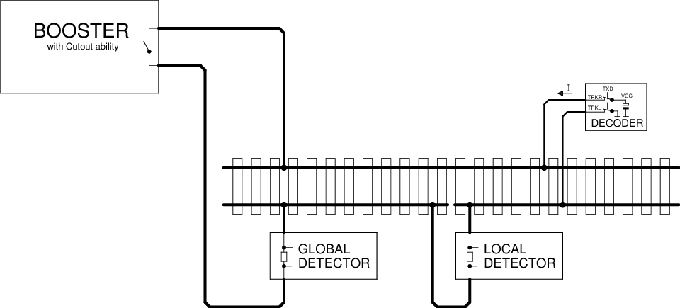
Figure 5: | Localized detector
Decoder locating a decoder in the above pattern can only work if the decoder is on the track section monitored by the Local Detector. However, this is problematic in the multi-traction operation. For this it is recommended that only the leading locomotive sends the ADR datagrams on channel 1, while on the following locos this function is deactivated via CV28. This can be done when assembling the vehicle network via POM.

Dynamic channel 1 usage
In this case, the sending of the address in channel 1 is automatically switched off in order to reduce collisions. The decoder sends in channel 1:
- After a restart
- After a change of address
- If it has not been addressed for more than 5s.
If bit 2 is set in CV28, the transmission in channel 1 will be switched off automatically after receiving the own locomotive address eight times. This will detect a new locomotive and, once addressed by the system, will no longer interfere with the detection of other locomotives.

Aufgleissuche
This is a special application to identify a vehicle on the plant. For this purpose, the vehicle is temporarily separated from the track voltage by dumping or by other means. After the decoder receives voltage again, it responds for a maximum of 30 seconds to the command "XF2 off" to the broadcast address 0 with its address in
Channel 2 . During this time, the user must trigger this command via the control panel.
Operating Command Response: EXT
► | short binary state control command "XF2 off" according to [RCN212] section 2.3.5 to the broadcast address 0: 1101-1101 0000-0010
◄ | Channel 2 from the decoder has three 12 bit datagrams  0001 (ID1) DDDD-DDDD : adr_high according to Table 10  0010 (ID2) DDDD-DDDD : adr_low according to Table 10  0000 (ID0) DDDD-DDDD : Time in seconds since the decoder has power again.
The decoder should not respond to every command "XF2 off" to the broadcast address 0, so that collisions in channel 2 may be reduced. These occur when another vehicle unintentionally had no voltage for a short time and therefore may respond. Over time since the decoder has tension again, the desired vehicle should be identifiable.

EXT (ID 3)
This feedback is used to transmit a location information. In this way, the location of the vehicle decoder of a given address can be determined and, if necessary, a filling of inventories triggered.

Send the location information
The location information may be sent by the decoder or the detector, depending on where the information is.
Case 1: Location information is present in the decoder (eg by infrared transmission)..
Operating Command Response: EXT
► | short binary state control command "XF1 off" according to [RCN212] section 2.3.5: 1101-1101 0000-0001
◄ | Channel 2 of the decoder: 0011 (ID3) 00 TTTT-PPPP-PPPP  With: TTTT = 0000 - 0111 : Location information (position):0PPP  TTTT = 1000 - 1111 : reserved  0PPP-PPPP-PPPP : 11 bit location address (position)
If the location information is present in the decoder, it can also be transmitted spontaneously in channel 2 with the ID DYN. See section 5.4.
Case 2: Location information is available in the Detector.
Operating Command Response: EXT
► | short binary state control command "XF1 off" according to [RCN212] section 2.3.5: 1101-1101 0000-0001
◄ | Channel 2 from Decoder:  0011 (ID3) 01 | Channel 2 from Detector:  TTTT-PPPP-PPPP  information  TTTT = 1000 : reserved  TTTT = 1001 : reserved  TTTT = 1 010 : Dieseltankstelle  TTTT = 1011 : Kohlebansen  TTTT = 1100 : Wasserkran  TTTT = 1101 : Besandungsanlage  TTTT = 1110 : Charging station (battery)  TTTT = 1111 : General filling station  PPPP-PPPP : 8 bit location address (position)
The Detector works as in Figure 5, but is supplemented by a RailCom transmitter. Since the location information is sent back across the track, a bus system is no further connection to the recommended procedure.

fill
The filling of a container or all containers takes place with the command "Byte Write" from Section 5.1.2 to the corresponding CVs in the RailCom block (CV31 = 0 & CV32 = 255).

DYN (ID 7)
This feedback is used to transmit dynamic information from vehicle decoders. Dynamic information refers to dynamic variables (DVs) that change during operation (eg speed, tank contents, etc.). RailCom CVs 64-127 (see Section 4.2.4, Table 8) correspond to DVs that can be changed by programming.
Operation Command Response: DYN
► | Operating command to decoder address according to [RCN212] section 2
◄ | Channel 2 18Bit [+ 18Bit]:  0111 (ID7) DDDD-DDDD-XXXX-XX  [ 0111 (ID7) DDDD-DDDD-XXXX-XX ]  with D = DV value and X = subindex for identification of the DV
The transmission of dynamic variables (DV) (eg speed, container, ...) takes place in an 18-bit datagram (ID7), which contains the 8-bit value of the DV ( D ) as well as a 6-bit subindex ( X ) of 64 possible DVs selected. The meaning of the DV is determined by the subindex.
2 arbitrary DVs can be transmitted in a feedback frame. Which DVs a decoder sends when he determines himself.
X | Meaning
0 | Real speed part 1 *  Values ​​between 0 and 255 are sent back from the decoder. 255 is maximum speed. The figures are in km / h (or mph). At higher speeds than 255 the difference is stored in part 2.
1 | Real speed, part 2 *
2 | reserved
3 | reserved
4 | reserved
5 | Flag Register, content yet to be determined
6 | Input register, assignment to be determined
7 | Reception Statistics: The vehicle decoder keeps track of all received DCC packets and transmits the number of bad packets / total in%. (Value range 0-100).
8 | Content of container 1 in% (value range 0-100)
9 | Contents of container 2 in% (value range 0-100)
10 | Content of container 3 in% (range 0-100)
11 | Contents of the container 4 in% (value range 0-100)
12 | Contents of the container 5 in% (value range 0-100)
13 | Contents of the container 6 in% (value range 0-100)
14 | Contents of the container 7 in% (value range 0-100)
15 | Contents of the container 8 in% (value range 0-100)
16 | Contents of the container 9 in% (value range 0-100)
17 | Content of the container 10 in% (value range 0-100)
18 | Contents of the container 11 in% (value range 0-100)
19 | Contents of the container 12 in% (value range 0-100)
20 | Datagram 1: Local address least significant 8 bits  Datagram 2: Local address Most significant 3 bits in bits 0 to 2 ,  bits 3 to 7 are reserved to 0.
21 | Status and alarm messages
22 | Trip odometer, exact definition yet to be determined
23 | Operating time, exact definition yet to be determined
24-63 | reserved
Table 11: Dynamic information vehicle decoder
* Note on transferring the real speed:
For example, the decoder calculates the actual speed on the system. This is multiplied by the scale, adjustable in the decoder is (for example, the value of H0 87). Result is the real speed. It is transmitted as km / h. Up to the value 255, the transfer takes place exclusively in ID 7 DYN0. If the speed is higher, only ( !) The difference (ie calculated speed in km / h minus 256) is transferred to ID 7 DYN 1. ID 7 DYN 0 will not be transmitted because it no longer contains relevant information.
In the case of the location address DV 20 , both address parts are to be transmitted in each case in an 18-bit datagram within a channel, whereby first the least significant 8 bits are transmitted. For addresses <256, a single datagram is sufficient.
The status and alarm messages for DV 22 are still to be determined.
The most significant bit determines whether the alarm is active is .
5.5 XPOM (ID 8 to ID 11)
POM means "Programming On the Main", ie programming on the track to drive. XPOM is an extended format for writing and reading up to four CVs in operating mode according to [RCN214] Section 5, compared to the POM defined in section 5.1. These instructions are used in channel 2 with a 36 bit datagram with the ID 8 = 1000 to ID 11 = 1011 and 32 data bits replied. The data bits contain the value of four consecutive CVs.
Operation: XPOM
► | Accessing Bytes or Bits According to [RCN214] Section 5  1110-KKSS VVVV-VVVV VVVV-VVVV VVVV-VVVV {DDDD-DDDD {DDDD-DDDD {DDDD-DDDD {DDDD-DDDD}}}
◄ | Channel 2 (36-bit): 10SS (ID8 - 11) DDDD-DDDD DDDD-DDDD DDDD-DDDD DDDD-DDDD  with D = CV data
Regardless of the number of bytes written and even if only one bit is written, the values ​​of four CVs are always reported back.
The assignment between command and response is carried out by means of sequence number SS and datagram ID as follows:
SS = 00 - ID 8 1000
SS = 01 - ID 9 1001
SS = 10 - ID 10 1010
SS = 11 - ID 11 1011
The response datagram associated with the XPOM command (ID8 ... ID11) does not have to be sent in the same packet frame, but can be done later.
The decoder must implement a queue for 4 XPOM commands and execute them in sequence. Repeatedly sent XPOM commands with the same sequence number are queued only once. The associated response datagram completes the operation and releases the corresponding entry in the queue. When writing via XPOM, the answer will be given after the actual writing process. In this way, the control panel can synchronize to the writing speed of the decoder. If the response datagram is missing, the last command with the same sequence number must be sent repeatedly. When writing read-only CVs, the decoder returns the current value of the CVs. Whether a write access has been accepted must be determined by the central office by comparing command and answer.
In particular, the decoder must support fast, block-by-block reading, ie, with consecutive XPOM read commands
the answer of the 1st XPOM read command at the latest in the cutout of the
3. XPOM read command to be sent
the answer of the 2nd XPOM read command at the latest in the cutout of the
4. XPOM read command to be sent
the answer of the 3rd XPOM read command at the latest in the cutout of the
5. XPOM read command sent to,
...
In this way is a very quick reading possible.

XPOM Byte Read
Operation: XPOM Byte Read
► | Bytes read according to [RCN214] section 5.  1110-01SS VVVV-VVVV VVVV-VVVV VVVV-VVVV
◄ | Channel 2 (36 Bit): 10SS (ID8-11) CV[V+0] CV[V+1] CV[V+2] CV[V+3]
At the time of the feedback , the preceding text must be observed.

Byte Write
Operation: POM Byte Write
► | Byte write according to [RCN214] section 5.  1110-11SS VVVV-VVVV VVVV-VVVV VVVV-VVVV {DDDD-DDDD {DDDD-DDDD {DDDD-DDDD {DDDD-DDDD}}}
◄ | Channel 2 (36 Bit): 10SS (ID8-11) CV[V+0] CV[V+1] CV[V+2] CV[V+3]
At the time of the feedback , the preceding text must be observed. The CV values ​​are always returned as they were after the write, even if the write operation could not be performed or only partially due to a limited range of values.

Bit Write
Operation: XPOM Bit Write
► | Bit Write entsprechend [Error: Reference source not found] Abschnitt 5  1110-10SS VVVV-VVVV VVVV-VVVV VVVV-VVVV 1111-DBBB
◄ | Channel 2 (36 Bit): 10SS (ID8-11) CV[V+0] CV[V+1] CV[V+2] CV[V+3]
Antworten wie bei "Byte Write". Der Befehl Bit lesen ist for RailCom uninteressant, da immer das ganze Byte zurückgemeldet wird.
Answers as in "Byte Write". The read bit command is of no interest to RailCom because the whole byte is always reported back.

Test Feature ID (ID 12)
The test feature ID are individual manufacturers the opportunity to develop new features Railcom to test and implement in products that can not be realized with the existing specification in the instruction set are .
For this, the manufacturer of the RailCommunity gets a number, which has to be entered in the CV130 of the RailCom block. This number can be used to differentiate between different applications. Default setting of the CV130 is "0".
The manufacturer agrees to give the RailCommunity the development goal and to provide a detailed description (as practiced in this specification for the other IDs) at the completion of the development.
The RailCommunity will publish the number assignment and the goals, as well as the description of the finished product in consultation with the manufacturer (at the latest on the market launch). This will allow other manufacturers to take advantage of this development as well. For regular use, however, another RailCom ID according to Table 5 must be used.

List of previously issued Test Feature IDs
This list shows the assigned Test Feature IDs with their intended use.
Test Feature ID (dec) | Purpose | Issued On
0 | Default
10 | Synchronization vehicle sound decoder with sound generators on the model railway | 28.03.2013
Table 12: Test Feature IDs

Application for accessory decoder (switches, etc.)

SRQ - Service Request for Accessory Decoder
Channel 1 of the cutout is used by accessory decoders to cause the panel to communicate. This request is referred to below as SRQ (Service Request).
The SRQ can be sent either to any accessory decoder package (no matter which address is addressed, whether it's a simple or extended accessory control package) or to a NOP if its own address is less than or equal to that in the NOP. (See chapter 4.3.4)
In the case of an SRQ after a NOP , the corresponding message in channel 2 has to be sent in order to save some time. However, if the SRQ is after a regular accessory decoder command, then the message must not be sent so that the messages of the addressed decoder are not obscured.
The SRQ is a 12-bit datagram. In contrast to all other datagrams, the SRQ contains no identifier, but the 12 useful bits are used to transmit the complete accessory address.
In the operation commands for accessories decoders are the address and data are combined so that the address is part of the specified command. Therefore, the entire command packet is shown here (but without sync bits and check byte).
Operating commands Accessory control:
► | Simple accessory control according to [RCN213] section 2.1  10AA-AAAA 1AAA-DAAR
► | Extended accessory control according to [RCN213] section 2.3  10AA-AAAA 0AAA-0AA1 DDDD-DDDD
► | NOP command for simple and advanced accessory decoder according to [RCN213] section 2.5  10AA-AAAA 0AAA-1AAT
◄  ◄ | Channel 1: 0 A10 A9 A8 A7 A6 A5 A4 A3 A2 A1 A0 (Simple accessory decoder)  Channel 1: 1 A10 A9 A8 A7 A6 A5 A4 A3 A2 A1 A0 (Advanced Accessory Decoder)
◄ | Channel 2 only in response to NOP: SRQ message, eg. B. Errors
Restricting the address resolution on Simple Accessory Decoders to output pairs, as well as the Extended Accessory Decoders, provides an 11-bit address and can thus distinguish between these two categories with the 12th bit of the SRQ datagram.
If a decoder has issued an SRQ, it must be repeated until it has been treated. The decoder must at this time no to respond to control commands directed.
An SRQ is considered treated if the decoder has received a clear command on its own address. The deletion command is the "coil off" command or the "absolute stop" command. In this state, the commands mentioned are not executed as such, but merely cause the SRQ to stop being sent.
Deletion command for simple accessory decoder: coil off
Format: 10AA-AAAA 1AAA-0AA0
Deletion command for extended accessory decoder: Absolute stop (= Aspect 0)
Format: 10AA-AAAA 0AAA-0AA1 0000-000
Note: A RailCom-enabled center regularly sends a NOP to enable SRQs. Receives an accessory decoder in the first 5 seconds after the first reception of the DCC format no NOPs, he may assume that the central RailCom capable not is , therefore no SRQ can be edited and he does not need to send. In this case , the function of the decoder is not blocked.

POM (ID 0)
POM means "Programming On the Main", ie programming on the track to drive. As accessory decoder usually fixedly connected to the digital signal for the operation are allow these commands the reading and writing of configuration variables in the operation mode corresponding to [RCN214] Section 2. These commands is in the channel 2 with a 12-bit datagram with ID0 = 0000 and 8 data bits answered. The data bits contain the value of the CV.
The POM commands from the central unit to the decoder (►) are noted without the addressing data. The addressing is done according to [RCN214] Section 2.1.
Operatione: POM
► | Access to Bytes or Bits According to [RCN214] Section 2  1110-KKVV VVVV-VVVV DDDD-DDDD  1110-10VV VVVV-VVVV 111K-DBBB
◄ | Channel 2: 0000 (ID0) DDDD-DDDD  with D = CV data

Byte Write
Operation: POM Byte Write
► | Read Byte command according to [RCN214] Section 2  1110-01xx
► | Channel 2 (12Bit): 0000 (ID0) DDDD-DDDD  with D = CV data.
The associated response datagram (ID0) does not have to be sent in the same package frame, but can be sent later. A central office must therefore ensure that the decoder is addressed again and no other command is sent to this decoder (the same is allowed).
When the reading process is complete is the decoder sends the result to the associated, again read command. If the decoder does not return the data within 0.5s then the read is considered failed.

Byte Write
Operation: POM Byte Write
► | Command Byte Write according to [RCN214] Section 2  1110-11xx
◄ | Channel 2 (12-bit): 0000 (ID0) DDDD-DDDD  Here , with D = CV data, the value returned after the POM operation in the CV is returned.
If the decoder does not return the data within 0.5s then the write is considered failed.
For a CV that can only be read, the decoder returns the current value of the CV.

Bit Write
Operation: POM Bit Write
► | Command Write bit according to [RCN214] section 2  1110-10xx
◄ | Channel 2 (12-bit): 0000 (ID0) DDDD-DDDD  Here, with D = CV data, the value returned after the POM operation in the CV is returned.
Answers like "Byte Write".

STAT1 (ID 4)
This feedback is used to transmit status messages from accessory decoders,
Part 1
Operation Command Response: STAT1
► | Operation command to decoder address according to [RCN213] section 2.1 or 2.3  10AA-AAAA 1AAA-DAAR or 10AA-AAAA 0AAA-0AA1
◄ | Channel 2 12Bit: 0100 (ID4) DDDD-DDDD
The status code can be returned as an acknowledgment after accessory decoder commands . An "ACK" can then be dispensed with..
1. Datagram
Bit | Meaning
11 ... 8 | Identifier 0x4
7 | Reserved
6 | 0: Initial state does not match the last received command.  1: Initial state matches the last received command.
5 | 0: the returned Aspect is the setpoint  1: the returned aspect is the actual value based on real feedback
4 ... 0 | Current Aspect. For example, turnout decoders have 2 output states, signal decoder (so-called extended accessory decoder) up to 31
Table 13: Status messages, part 1

TIME (ID 5)
This confirmation is used to transfer the forecast round trip time
Operation Command Response: TIME
► | Operation command to decoder address according to [RCN213] section 2.1 or 2.3  10AA-AAAA 1AAA-DAAR or 10AA-AAAA 0AAA-0AA1
◄ | Channel 2 12Bit: 0101 (ID5) DDDD-DDDD
This command confirmation can be returned as an acknowledgment after accessory decoder commands . An "ACK" can then be dispensed with.
The 7 low-order bits of the remaining term characterize the runtime until the end condition of this term is reached (predicted orbital period). The time is given in 1/10 seconds (MSB = 0) or 1 second (MSB = 1) depending on the MSB . A time of 0 means no switching time - eg with signal decoders without light bulb simulation. This results in a value range 0 ... 12 , 7 seconds or 0 ... 127 seconds.
1. Datagram
Bit | Meaning
11 ... 8 | Identifier 0x5
7 | 0: resolution 1/10 second  1: Resolution 1 second
6 ... 0 | Forecasted round trip time
Table 14: Forecasted round trip time

ERROR (ID 6)
This feedback is used to transmit error information
Operation Command Response: ERROR
► | Operating command to decoder address according to [RCN213] section 2 (including NOP)
◄ | Channel 2 12Bit: 0110 (ID6) DDDD-DDDD
The error code may be returned after each instruction addressing the decoder, including NOP. An "ACK" can then be dispensed with.
The error message transfer is cleared by a new switching command. If there is a permanent error, the decoder must not trigger a new SRQ, as long as the same error exists. The central office must therefore address the decoder again after the deletion to determine whether it is a permanent error.
Bit | Meaning
11 ... 8 | Identifier 0x6
7 | Reserved
6 | 0: There is only the error specified in the following 6 bits.  1: There are other errors besides the one given.
5 ... 0 | error code | meaning
5 ... 0 | 0x00 | No mistake (more)
5 ... 0 | 0x01 | Command could not be executed, unknown command / invalid aspect.
5 ... 0 | 0x02 | Current consumption of the drive too high.
5 ... 0 | 0x03 | Supply voltage too low, the function is not ensured.
5 ... 0 | 0x04 | Fuse defective.
5 ... 0 | 0x05 | Temperature too high.
5 ... 0 | 0x06 | Feedback error (unwanted adjustment detected)
5 ... 0 | 0x07 | Manual adjustment (eg by a button on the decoder)
5 ... 0 | 0x10 | Switch lantern or signal lantern broken
5 ... 0 | 0x20 | Servo defective.
5 ... 0 | 0x3F | Internal decoder error, eg self-test processor checksum faulty.
Table 15: Error Messages

DYN (ID 7)
This feedback is used to transmit dynamic information from accessory decoders. "Dynamic information" refers to CV contents (RailCom CVs) that change during operation.
Operation Command Response: DYN
► | Operation command to decoder address according to [RCN213] section 2.1 or 2.3  10AA-AAAA 1AAA-DAAR or 10AA-AAAA 0AAA-0AA1
◄ | Channel 2 18Bit+[18Bit]:  0111 (ID7) DDDD-DDDD-XXXX-XX  [0111 (ID7) DDDD-DDDD-XXXX-XX]
The transmission of dynamic variables (DV) takes place in an 18-bit datagram (ID7), which contains the 8-bit value of the DV (D) and a 6-bit subindex (X), which selects one of 64 possible DVs. The meaning of the DV is determined by the subindex. Any two DVs can be transmitted in a feedback frame. Which DVs a decoder sends when, he determines himself.
X | Meaning
0 | Flag Register, content yet to be determined
1-63 | Reserved
Table 16: Dynamic Information

XPOM (ID 8 to ID 11)
These confirmations correspond to those for vehicle decoders. Therefore, reference is made to section 5.5.

STAT2 (ID 8)
Does not serve for new designs, but is already used by components on the market. In other use of the ID8, the length of the datagram is used as a distinguishing feature.
This feedback is used to transmit status messages from accessory decoders
Part 2
Operation Command Response: STAT2
► | Operation command to decoder address according to [RCN213] section 2.1 or 2.3  10AA-AAAA 1AAA-DAAR or 10AA-AAAA 0AAA-0AA1
◄ | Channel 2 12Bit: 1000 (ID8) DDDD-DDDD  with D = data according to Table 17, bits 7 ... 0
Specially tailored for mechanical adjustments.
- Datagram
Bit | Meaning
11 ... 8 | Identifier 0x8
7 ... 4 | Configuration, previously set:  0000 - decoupler  0001 - switch  0010 - three way switch  0011 - Double intersection  1000 - track lock signal  1001 - shape signal Hp0 / Hp1  1010 - Shape signal Hp0 / Hp1 / Hp2  1011 - Advance signal Vr0 / Vr1  1100 - Advance signal Vr0 / Vr1 / Vr2  1101 - Railway barrier
3 | 0: The state reported in bits 2 ... 0 corresponds to the setpoint value, or  "Setting process is still going on".  1: The reported status corresponds to the actual value based on real feedback.
2 ... 0 | Current state
Table 17: Status Messages, Part 1

Appendix A: References to other Standards

A.1 Links to Referenced RCN‘s
[RCN210] RCN-210 DCC packet structure
[RCN211] RCN-211 DCC packet structure
[RCN212] RCN-212 DCC Operation Commands for Vehicle Decoder
[RCN213] RCN-213 DCC Operation Commands for accessory decoder
[RCN214] RCN-214 DCC configuration commands

A.2 Informative Links
The standards and documents listed here are for information only and are not part of this [RCN225] RCN-225 DCC configuration variables
[S922AA] NMRA: S-9.2.2 Appendix A DCC Manufacturer ID codes
Appendix B: History
date | chapter | Changes from the previous version | Version
02/12/2018 | 4.3  to  6.8  1.1 & 1.2  2.2  2.5  3  3 & 4.2.1  3.1 & 3.2  4.2.1  5.1.2  5.2.1  5.2.2  5.3.1  5.4  5.5 & 6.7 | Basic revision with DCC package definitions only informative and references to the corresponding RCN  Sections 1.1 and 1.2 adapted accordingly  New: High-power RailCom  Feedback NACK  All possible datagram combinations permitted  Long address 3 instead of 253 as programming address  Revised sections 3.1 and 3.2 List of IDs.  CV 28 adjusted according to other changes  Response at Byte Write specified  New: Dynamic Channel 1 usage  New: Track Search  Sending Location Information: Letter P instead of O  Further DV defines  new: XPOM | 1.1
18/12/2016 | All | First version based on specification RailCom V 1.4 from April 2015 by Lenz | 1.0

gemäß RailCommunity Vorschlag vom 07.09.2018 According to RailCommunity proposal from 07.09.2018
gemäß RailCommunity Vorschlag vom 07.09.2018 According to RailCommunity proposal from 07.09.2018

